DIGITAL MATERIALITY: THE HIDDEN INFRASTRUCTURE BEHIND DIGITAL LIVES

Clara Popescu

Creative Computing BSc

University of the Arts London

January 23, 2025

Introduction 2

Physical and Environmental Impact 2

Social and ethical Impact 3

Key Practitioners 4

Conclusion 7

Bibliography 7

## Introduction

Networks have proven to be a fundamental part of a functioning society. They are the base of social interactions, economic exchanges, and global communication.   
In everyday life, they signify more than a just a mere physical connection; they represent intricate relationships that shape how humans and entire ecosystems connect with one another, share ideas, and collaborate. Networks are interpersonal and social. They influence how societies operate, grow, and evolve.  
With the rise of computational technologies, these networks have become more structured and complex. The growth of digital infrastructures has transformed how humans communicate and, most importantly, it has enabled unprecedented connectivity and data sharing.   
However, this connectivity comes at a significant cost. The demand for faster, more efficient networks has led to the construction of massive data centres, the extraction of rare earth minerals, and the generation of electronic waste, all of which place pressure on the planet's resources.

This essay will analyse the social and environmental impact of the seemingly immaterial digital era, and how its consequences manifest in the real world. It will explore how the production and use of technology contribute to resource exploitation, environmental degradation, and the human cost of sustaining digital infrastructures.

## Physical and Environmental Impact

The digital world is often perceived as abstract or vague, however the theme of digital materiality brings out the harsh truth that these technologies are deeply embedded in the physical world. These systems rely on tangible infrastructures such as data centres, cables, and hardware, all of which require labour, resources, and energy to build and maintain. Online storage and services are most of the time encouraged and seen as superior compared to their physical counterparts, with the misconception that they are more environmentally friendly. This connection between the seen and unseen, is not always obvious, however, it is crucial to point out the immense network of labour and assets required to create digital devices. Practitioners like Kate Crawford and Valdan Joler, highlight the importance of this through maps, videos, and books, offering a comprehensive insight into the industry.

Moreover, pieces such as The Submarine Cable Map *(TeleGeography, 1999)* and Satellite Xplorer *(ESRI, No Date)*, point out aspects of the physicality of digital materials that remain invisible to most people. From the seabed to the outermost layer of the atmosphere, these vast networks form the backbone of global communications and sustain digital lives.

“The cloud” often elicits images of something intangible, but its presence in the physical world cannot be avoided. The cloud is not an ethereal presence, but rather a collection of networks, data centres and servers – the structure that forms the foundation of all things digital.   
  
As the data centre sector is experiencing a steady increase *(see Figure 1)*, the environmental impact is bound to become more negative. Currently, large data centres consume the equivalent amount of electricity needed to power between 350,000 and 400,000 electric cars each year *(Spencer and Singh, 2024)*. This excessive consumption of electricity contributes significantly to carbon emissions and increases the strain on global energy resources.

Figure - IEA (2024), Investment in data centres in the United States, January 2014 to August 2024, IEA, Paris https://www.iea.org/data-and-statistics/charts/investment-in-data-centres-in-the-united-states-january-2014-to-august-2024, Licence: CC BY 4.0

Russian duo EEEFFF, stage a performance outside a data centre titled “Picnic near data-centre – see where the internet lives” *(EEEFFF, 2016)* along with some acquaintances they met through the internet. They describe the internet’s home as a “the safest place to be” surrounded by “barbed wire, fences, and concrete bays”. Once seen as a disembodied space, the cloud is linked to tangible locations. Picnic near a data centre serves as a reminder that the internet’s impact extends beyond the screen, changing both our environment and understanding of space and security.

## Social and ethical Impact

The ethical and social implications of digital materials are commonly an afterthought, but increasingly important and relevant in today’s world. As digital technologies integrate into all aspects of life, the true price paid for their production often includes labour exploitation and poor working conditions.  
Agbogbloshie in Accra, Ghana is the world’s largest electronic waste (e-waste) dumping site *(Agbogbloshie: The world's largest e-waste dump – in pictures, 2014)* where workers are hired to dispose of electronic devices by burning them. Most of them, teens, and young adults, suffer of debilitating conditions due to the exposure of toxic chemicals. As a result, the majority of them die from cancer in their twenties. While this is the most severe consequence of this process, wildlife and air quality are also negatively impacted. Animals are walking through fields of burned material and the substances released contaminate the environment, posing serious threats to surrounding ecosystems.  
This grim reality reveals the disguised human cost of digital consumption, where the drive for innovation overlooks the lives and health of those most vulnerable.

South American communities are also greatly affected by the extraction of natural resources, more specifically lithium, a base component in most electronic devices. With 60% of the world’s lithium deposits located in Bolivia, Argentina, and Chile, also referred to as the ‘lithium triangle’, this region has become a focal point for the global demand of lithium. While the extraction of this precious material presents significant economic development opportunities, it has also led to harmful side effects for the biodiversity, and water resources. The method used to extract these minerals demand vast quantities of water, which places additional strain on local water supplies, in regions where there is already a limited amount of it (*Chan and Devia-Valbuena, 2023).*   
As a result, local communities are put at risk due to limited supply of water. The exploitation of natural resources in one part of the world is deeply linked to digital economies and technological infrastructure elsewhere, illustrating how global networks can have profound consequences on different nations.

Control over ‘the cloud’ and infrastructure can become a source of geopolitical power in the modern world. The United Stated stands at the forefront of this global phenomenon, hosting around 5,400 data centres, which places it far ahead of any other nation in terms of control over data storage and processing. Germany ranks second, with approximately 520 data centres, while the United Kingdom follows closely behind, hosting around 515 *(Taylor, 2024)*. This gives these countries significant influence over global data and digital services, raising concerns about privacy and the potential for misuse of personal data, as well as questions about consent in the digital landscape.

## Key Practitioners

The exploration of digital materiality and its social implications has been an existing theme for many artists and researchers, including Kate Crawford.   
She is an Australian scholar, writer, and artist whose work critically examines the intersection of artificial intelligence (AI), society and environment.   
As a leading voice in the topic of digital materiality, Crawford calls attention to the hidden network of infrastructures that fuel AI systems, highlighting the implications of their development. Her work challenges the perception of AI as a neutral, abstract force, emphasizing the materials and often exploitative systems that sustains it. Through her research and artistic practice, Crawford pushes for a more ethical, transparent, and sustainable approach to the technologies that shape our world *(Kate Crawford).*

Her latest book, “Atlas of AI: Power, Politics and The Planetary Costs of Artificial Intelligence” follows the process of developing an AI system, from minerals drawn from the earth such as lithium, to the labour of the low-wage workers who assemble and maintain these technologies. The book highlights how the physical resources and human labour are an integral part of AI systems and how their cost is often hidden from public view.

It emphasises that the real-world networks of power, politics and environmental harm are crucial to understanding the true price paid of AI systems.

Similarly, Valdan Joler is an artist and researcher whose work focuses on the algorithmic transparency, digital labour and the relationship between technology and society *(Vladan Joler, 2019)*. Joler deconstructs the complexities of supply chains, electronic waste and the exploitation embedded in digital technologies, through striking visualisations and data-driven art. His practice not only analyses and critiques data sets but also visualises them in clear and accessible manner.  
In one of his most notable projects titled “New Extractivism”, Joler depicts the force of gravity as big corporations and the user / consumer being sucked into a Black Hole, passing the point of no return *(see Figure 2)* *(Joler et al., 2021)*.

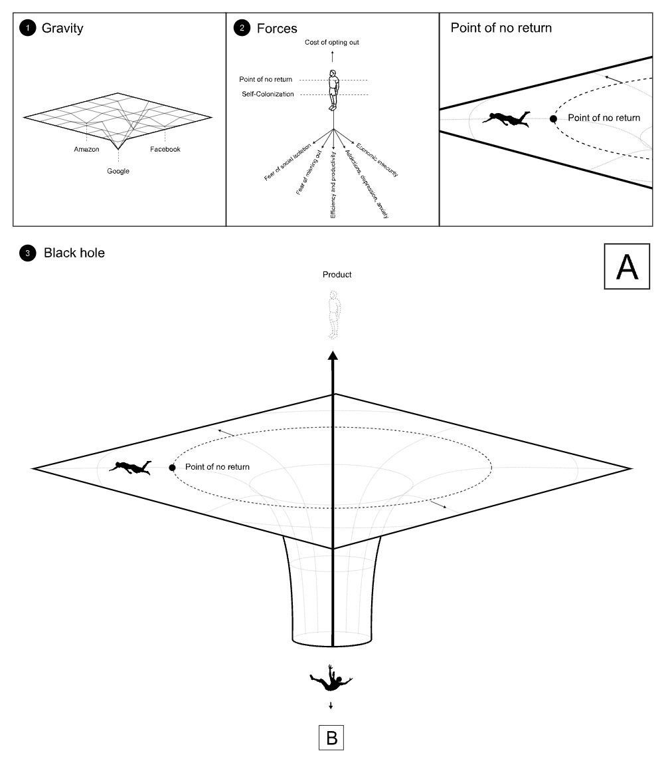

Figure - New extractivism (2021) New Extractivism. Available at: https://extractivism.online/

This imagery speaks for the exploitative and unsustainable nature of modern digital economies. Users are drawn into a cycle of consumption and waste with no clear purpose or exit. After a certain degree of consumption, it is practically impossible to go back to a life without these technologies. The digital economy promotes an unsustainable system, generating massive e-waste, all while offering little to no tangible benefit.  
While the networks of resource extraction and waste disposal may seem separate, the user plays a key role in connecting these systems, benefiting from them without fully acknowledging their environmental and ethical costs.

The word ‘extractivism’ has been used throughout history when referring to the practice of exploitation and appropriation of natural resources for economic gain. (Kröger et al., 2021). By using this term in the project’s title, Joler is drawing attention to how the large-scale extraction of natural resources causes ongoing problems like inequality and environmental destruction. This clearly highlights how these practices continue to negatively affect both people and the planet.

Crawford and Joler collaborate to create the Anatomy of an AI System *(Crawford and Joler, 2018)*, a project that dissects a virtual assistant, unpacking the complex web of resources needed to bring such device into existence. Presented in the form of a detailed map, the project visually traces the supply chains, materials, energy usage and labour involved in the production of assistive technologies. Through this powerful visualization, Crawford and Joler reveal the invisible infrastructure of AI, making it more tangible and urging a deeper reflection on modern technological conveniences.

Kate Crawford and Valdan Joler both explore the hidden realities of digital materials, however Crawford, as an academic and researcher, delves deeply into the socio-political and environmental impacts of technology. Her approach is rooted in extensive research, data analysis, and critical examination of AI systems.  
Joler, on the other hand, is more visually oriented and uses metaphorical and visual imagery to convey the reality that the ‘invisible’ digital world is built on a wide system of resources and labour.

## Conclusion

Given the growing reliance on digital technologies in the recent years, it is critical to understand the materials required to build them. From the current and future negative impact it has on the planet, to the exploitation of the people involved in their production, it is essential to appreciate this unseen cost. Recognising these truths, as explored by thinkers like Kate Crawford and Valdan Joler, encourages more responsible and sustainable practices in the development of technologies. Moreover, by considering the full life cycle of digital devices, from extraction to disposal, it is easier to understand the long-term consequences of our consumption.  
All things considered, the responsibility does not rest solely on the manufacturers and tech companies. The constant demand from the users and their digital consumption habits directly contribute to the environmental and social impact of cyber infrastructures. Ultimately, a holistic approach that considers the interconnectedness of technology, people, and the planet is needed to create a more sustainable and just digital future.

Bibliography

*Submarine Cable Map* (1999). Available at: https://www.submarinecablemap.com/ (Accessed: 17 January 2025).

*Satellite map: Explore active satellites orbiting Earth* (no date) *Satellite Map | Explore Active Satellites Orbiting Earth*. Available at: https://geoxc-apps.bd.esri.com/space/satellite-explorer/ (Accessed: 17 January 2025).

*Thomas Spencer and Siddharth Singh (2024) IEA* *What the data centre and Ai Boom could mean for the energy sector – analysis*, *IEA*. Available at: https://www.iea.org/commentaries/what-the-data-centre-and-ai-boom-could-mean-for-the-energy-sector (Accessed: 20 January 2025).

*EEEFFF: Picnic-near-data-centre* (2016) *EEEFFF.ORG - picnic-near-data-centre*. Available at: https://eeefff.org/en/projects/picnic-near-data-center.html (Accessed: 17 January 2025).

*Agbogbloshie: The world’s largest e-waste dump – in pictures* (2014) *The Guardian*. Available at: https://www.theguardian.com/environment/gallery/2014/feb/27/agbogbloshie-worlds-largest-e-waste-dump-in-pictures (Accessed: 17 January 2025).

*Petroc Taylor* (2024) *Data centres worldwide by country 2024 | Statista*. Available at: https://www.statista.com/statistics/1228433/data-centers-worldwide-by-country/ (Accessed: 20 January 2025).

*Kate Crawford* (No date). Available at: https://katecrawford.net/ (Accessed: 18 January 2025).

*Vladan Joler* (2019) *Future Everything*. Available at: https://futureeverything.org/profile/vladan-joler/ (Accessed: 18 January 2025).

*Valdan Joler* (2021) *New Extractivism*. Available at: https://extractivism.online/ (Accessed: 18 January 2025).

*Kröger, M., Hagolani-Albov, S. E., & Gills, B. K. (2021). Extractivisms. In C. P. Krieg & R. Toivanen (Eds.), Situating Sustainability: A Handbook of Contexts and Concepts (pp. 239–252). Helsinki University Press.*

*Kate Crawford and Valdan Joler* (2018) *Anatomy of an AI System*. Available at: https://anatomyof.ai/ (Accessed: 18 January 2025).

*Luke Chan and Nicolas Devia-Valbuena* (2023) *In the global rush for Lithium, Bolivia is at a crossroads | United States Institute of Peace*. Available at: https://www.usip.org/publications/2023/12/global-rush-lithium-bolivia-crossroads (Accessed: 20 January 2025).